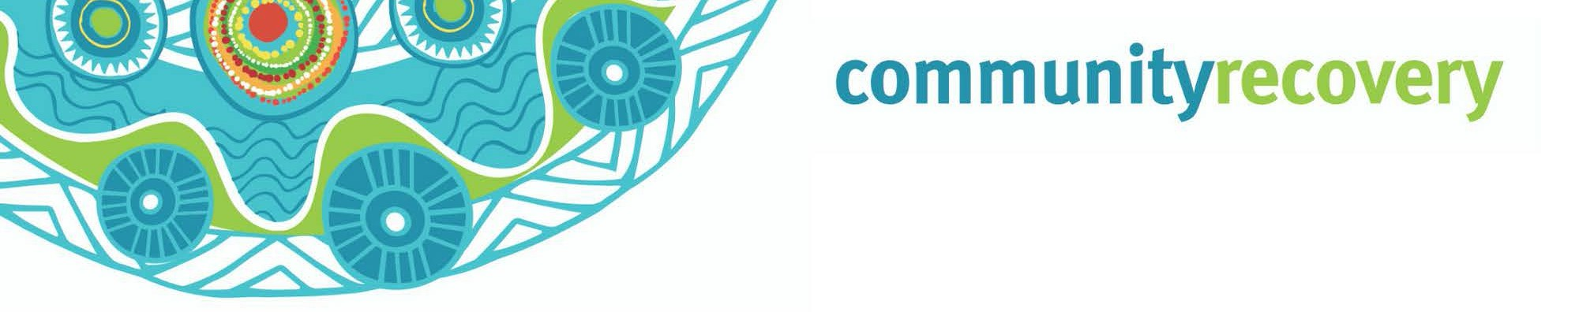

Wunt tha’iy an a kaap an thee uwalan ang ngamp an erkam ma yalmathnak yuk waymin anangan.

Thum Nhoom Inan Kankanam Lat



Ngeen thum nhoom?
Wantak an nintang wantiw?

Aak kangk anman ya’a, aak palpuw an thum nhoom ngan thum pikan a thok an theen.

Ngamp yotmin aak in punchan Queenslanders thathamp a thum nhoom ak an.

Thum nhoom aak nungerang an ang, ngantam ngeeyan a wik an maman a wik an yumpan.

Weewan ang ngan ngeey ee an thowan ang aniy neenthakam wayathan a.

- Nint thum nhoom thinth wun ngan ey?

- Aak nint an wun ngan aak thum nhoom pench ey?

- Nint kangk yot nungerang an iya?

- Awuch nungkeram an wuuyan nang a wunan ey?

Inan Thathan www.ruralfire.qld.gov.au

A RACQ Get Ready Queensland, www.qld.gov.au a www.ruralfire.qld.gov.au thathan
- An nint kemp wee weeyam a kemp waay ngank wee weeyam wunin. An nint ke weep wunin, weep wayathin, man kul a ngak ul mungkin. Kampan nungkeram an minam pian thanang a nungkerak man thamp. May minh min mungkan, weep min wunan, a tv thathan a radio ngeeyan.
- Nint puk thamp ay? Ma pathathan thanang ang, ke than waawaa ayn yootant kaap an, ngank min wunan. Waa’an wanakan wanch pam yoot ngan ma aathan than wee weeyan kampan aak min koyam yumpayn. A puk many niindam an yipmam ngank min wunayn
- Ku a ku waak a minh bullock, minh ninthan (pig) thak an ney ay? Ma yalmathan thanang a yipmam minam wunayn aak kaap ngan. Nint aak min uwan thant yipmam angan wunayn, a may ngeen an munkayn, aak petch we’irr uwan a. Engkan ku a ku waak an ang man wantin thangang weey alathanang.
- Awuch a yuk waymin nungkeram an thuthnam ulan wunin. Nint kan minam aak aniy yumpan ay? Nint insurance thamp awuch yumpayn a yuk waymin an koyam thee’ayn ay?
- Nintang ma yalmathan ayn ang a anan nungk ma aathayn an nintang, yipmam anman min yuk waymi thak an pian. Nint ngul awuch ak an.

Ma yalmathan thum nhoom mam:

- Ma yalmathnak awuch ngan ang, ngantam ngeeyan thum nhoom a yipmam minan wunan aak kap thonam ngan. Awuch thak an minam yumpanak ang wiy an yipmam minam thamp.

- Ma yalmathan yuk waymin opirr ak an: Ma yalmathan yuk waymin opirr ak an aak kap thonam akam, kankanang kaap’am.
Inan thatan https://getready.qld.gov.au/be-prepared/
Ma yalmathnak kankanang wunt

- Ma yalmathan aak pech wantan Wik yumpan ngeen awuch ngan yuk waymin thak an umpan.
- Pam wanch nungkerang thinth an a wunthan, thanang ma aathan a waa’an ngan an umpayn.
- Ku a Ku’waak an keengk keengk kon ngam pekan yipmam karrpam kalan.
- Ngeeyan yuk radio a tv ngan thathan yipmam nungk waa’ow wantin an ngak a wuntan iy.




Download the
Self Recovery app
Visit our website www.qld.gov.au/ communityrecovery

