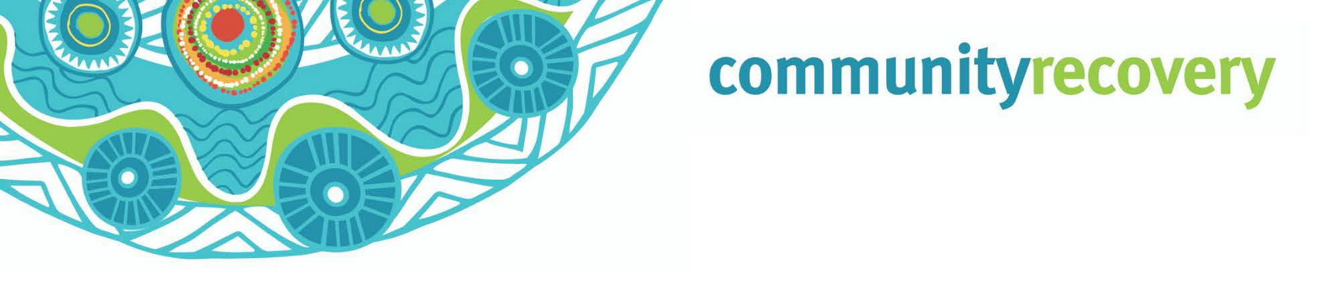When e gor come po mina nuthakyn bad weather ya weh Qld, e nor gad time po’ think bout ‘ip’ e gor happen, mepla have to think bout ‘what time’ e gor happen.

If we meke plan straight now, e gor be easy po’ pixem

How por Ready Yuplaself por wan Bushfire

Wanem e Bushfire?
Yu no have to stap gad the bush po ol bushfire por hurteh yu – yupla only have to stap klustoon po all something e be get burnt ene gad smoke en embers.
Yumpla everybody should sabe wanem them official bushfire warning level en meke plan of action por’ mek sure yupla gor survive.
When e gad bushfire klustoon yu, e up to yu por mek sure yu tek notice, pind out ol information and meke decisions ene act quickwan.
Everybody should be ready in case e gad bushfire,
but if yu go speak wa po any them question ya, then e more dangerous por you.
- Yu stap few kilometers from bushland ah?
- E be gad any bushire lo local area bor you be happen before?
- E gad ol tree’s ene shrubs cloostoon 20 metres away from house blo yu ah?
- House bor you e built on one hill side slope ah?

Ip yu wande pind out mor go there por www.ruralfire.qld.gov.au

Source: RACQ Get Ready Queensland, www.qld.gov.au and www.ruralfire.qld.gov.au

Wanem problems e might gor mekem por yu?
- E can cause yu por mood swings. Waseh might yu can’t sleep or e hard por focus en’e sum pipol wase wande drink caus ol e fil mina wild weh ol something. Yu muss loogout yourself prapa po’ lookout pamle bor yu. Yu might gor cause ol health problems ip yu nor gor kai kai en sleep. E good yu gor still socialize weh ol nuther pipol an pamle lo Facebook.
- You gad pikinini ah? Mek shor thempla feel safe, no more panic, en’e meke ol’ normal duties bor yu weh house. Try nor por let e dhempla luk weh tv ene’ listen ol radio warnings. Nor let e thempla listen ol big marn talk about the storm - bombie ol e gor fright. Yarn po’ dhempla wiskine ol pamle’s gor clean up apta en keep seek po’ thempla ‘ol everything go be right’.
- Yu gad pets or livestock? E mina important yu meke plan po dhempla so ol go be olrite weh the storm! Think about weh dhempla gor stap, wannem kai kia en exercise ol go need en ip thempla e orite weh ol nuther animals ah pipol. Pind out ip e olrite po tekem gor por the evacuation centre.
- Ol belongings bor yu might gor dammiz lor the storm en’e yu gor have to replace dhemwan. Yu be put away dhem something bor yu prapa? Yu gad insurance po’ pixi house bor yu an replace dhem something blo yu?
- Yu provide e care po sombebody whoda elderly lo house bor thempla ah? E good you go meke plan lo dhempla an ol e gree an yu mek sure ol e gor gad support en’e dhempla gor feel safe en’e well.

Mekeh everything ready por Bushfire:

  - Meke house ene business blor yu straight: mek sure yu sabe the local bushfire risk an yu sabe wanem por mekem ip e gor gad. Ip property blo yu e nor ready e gor be at risk en e gor mekem more dangerous por ol neighbours bor yu
  - Meke one emergency bag: meke ol something stret ol the time ene 3 months before storm season gor come. E mina important yu gad wan emergency bag ready, dhiswan e help e yu po’ stahp strong en survive weh ol nuthakyn bad weather.

  - Mekem straight po gor: Talk weh ol pamle so yupla gor sabe wanem po’ mekem ene meke wan list so yupla nor figet ol something.
Go dher lo https://getready.qld.gov.au/be-prepared/ por find out more about wiskine yu meke everything ready po one disaster.

    - Look out po ol neighbours blo you: meke friend weh them neighbours blo yu ene aske thempla if ol need help weh anything. When the cyclone e ober, gor find out weh thempla ip ol e orite e’ne talk por thempla about wanem yu gor mekem.
    - Planeh emergency po’ ol pet: yu might can’t thek e them pet weh yu gor po’ ol shelter so yu gor have to meke nother plan en’e emergency kit po’ ol pet blo yu.
    - Put yu name down for warnings en alerts en’e tune in: talk po’ council bor yu speak thempla po’ put e name blo yu down po’ gedi ol warnings en alerts. Listen po’ the radio en watch tv po’ sabe wanem e happening weh the weather or yu can gor po’ the Bureau of Meteorology website.



Download the

Self Recovery app
Visit our website www.qld.gov.au/ communityrecovery

