Earthquake

This factsheet is about what to do in an earthquake.

An earthquake is when the ground shakes.

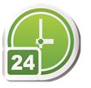
Earthquakes can:
- happen at any time
- be big or small
- be dangerous.

Dangerous means you can get hurt. For example, something can fall on you.


What can an earthquake do?
An earthquake can hurt you and your family.

An earthquake can damage your:
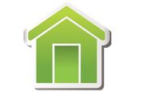
- house

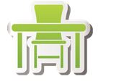
- things in your house, for example furniture

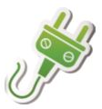
- essential services, for example electricity.

Damage means to break something.
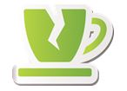

How can I get ready for an earthquake?
To get ready for an earthquake you should:

- have an emergency kit
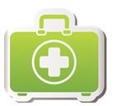

- plan what you and your family will do if there is an earthquake warning
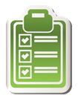

Earthquake

- get insurance for your house and things in your house. Insurance is money you might get from an insurance company when something goes wrong
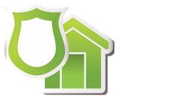

You should also:

- listen to ABC radio or TV for earthquake warnings

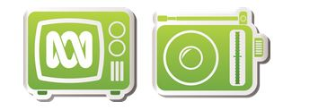

- make sure things in your house will not fall on you

- visit our website
https://getready.qld.gov.au/be-prepared/
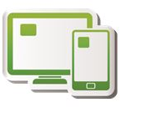

More information
https://www.qld.gov.au/communityrecovery



