Severe weather
This factsheet is about what to do in severe weather.

Severe weather might be:

• strong winds



• big thunderstorms



• large hail

Severe weather can:


• happen at any time

• be dangerous.



Dangerous means you can get hurt.

What can severe weather do?

Severe weather can hurt you and your family.

Severe weather can damage your:


• house

• things in your house, for example furniture.



Damage means to break something.



How can I get ready for severe weather?

To get ready for severe weather you should:

• have an emergency kit



• plan what you and your family will do if there is a severe weather warning

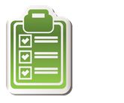

• get insurance for your house and things in your house. Insurance is money you might get from an insurance company when something goes wrong.

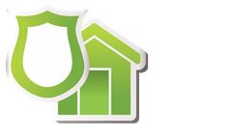

You should also:

• listen to ABC radio or TV for severe weather warnings



• make your house and garden safe.

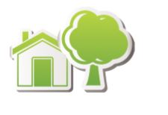

Severe weather

• visit our website https://getready.qld.gov.au/be-prepared/



More information

https://www.qld.gov.au/communityrecovery



