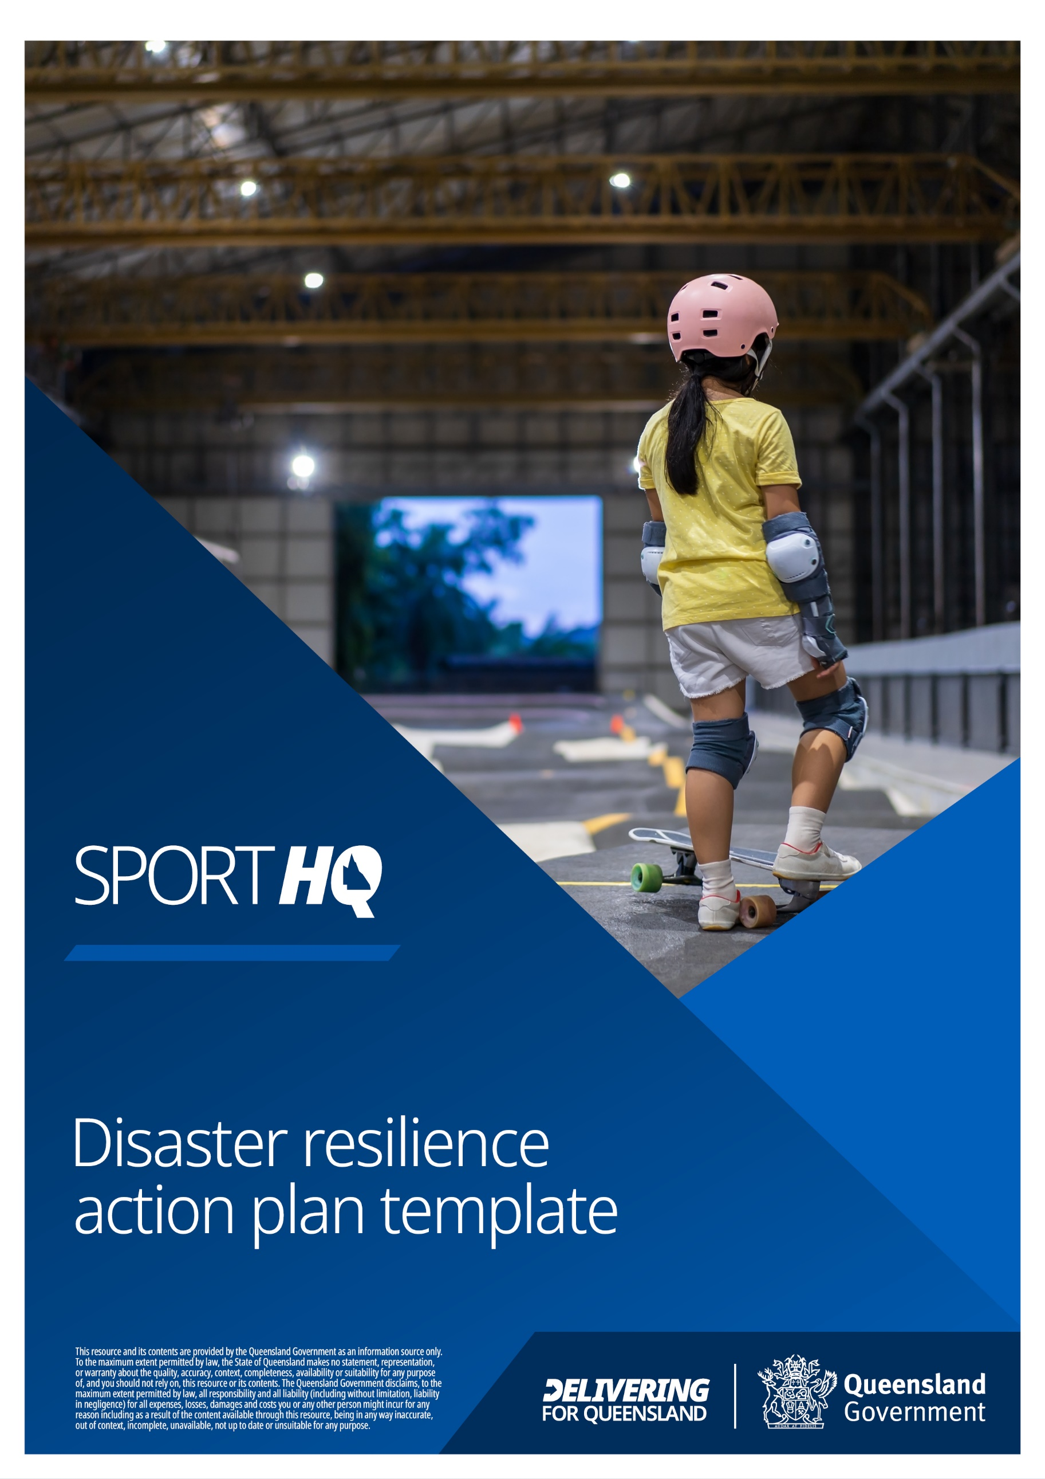

Table of contents
Purpose 3
Objectives 4
Implementing the action 5
External contacts 7
Prevent and prepare action plans 8
Respond action plans 15
Recovery action plans 17
Other disaster recovery action 23
Monitor and review 24
Supporting resources 25

The information presented in this guide:
- is general in nature and does not consider your organisation’s specific situation;
- is correct at time of publishing; and
- should not be considered as legal advice.
Purpose
Queensland, with its diverse range of environments from idyllic coastal villages and rural townships to bustling cities and thriving business hubs, is a stunning state. However, its location makes it prone to natural disasters such as flooding, storms, cyclones and bushfires. These disasters can significantly impact community facilities, either directly through damage to physical structures and equipment, or indirectly through disruptions to power, communication and transport services.

To ensure that organisations in Queensland are well-prepared to deal with natural disasters, a disaster resilience action plan template has been developed. This plan provides support and guidance to organisations in effectively preparing for, responding to and recovering from natural disasters. It is effectively a ‘live’ document that will require regular review and updating to ensure its ongoing applicability. By implementing this plan, organisations can better protect their premises, stock and equipment, as well as ensure that essential services are not disrupted during times of crisis.

Ultimately, the goal of this disaster resilience action plan is to ensure that Queensland remains a safe and resilient place to live, work and play, even in the face of natural disasters. By taking proactive measures to prepare for and mitigate the impact of natural disasters, organisations can help to safeguard the wellbeing of their members and the wider community. By implementing an effective disaster resilience action plan, organisations can:

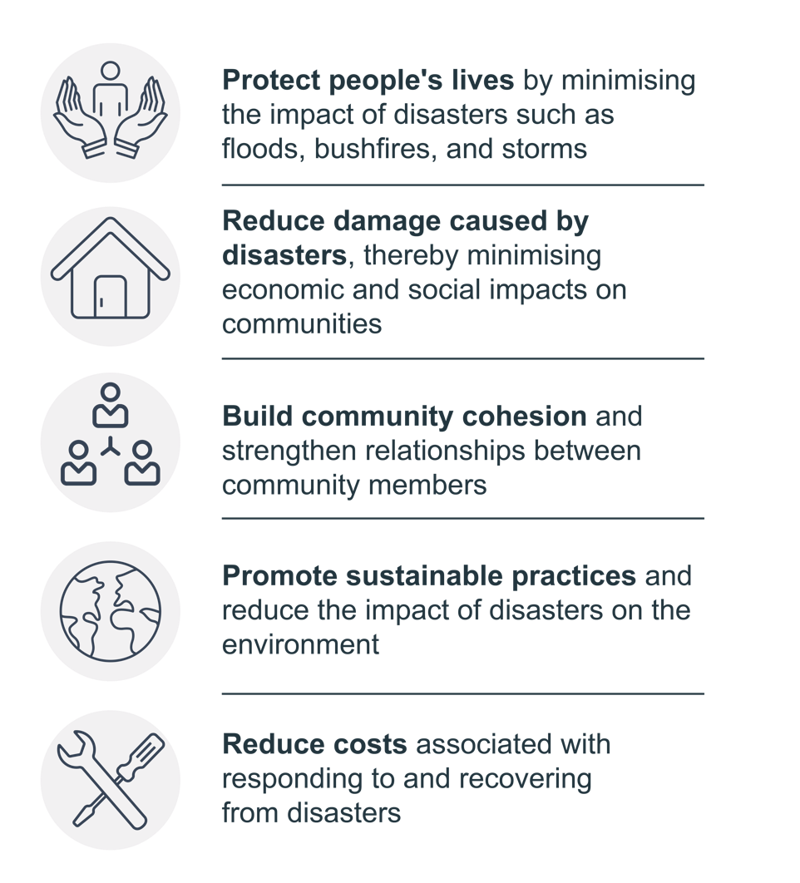

Objectives
The goals of our disaster resilience action plan are:
Insert your organisation’s disaster resilience action plan goals here
E.g.
- We can provide an adequate level of service to our members before, during and after an emergency
- Our volunteers / staff are well prepared to cope with an emergency
- Through strengthening our organisation’s disaster resilience, we strengthen the resilience of our whole community
- Our organisation is well positioned to work with our community to ‘build back better’ after an emergency

Implementing the action plan
The PPRR Framework
The PPRR disaster framework is a widely recognised approach to disaster management and response that involves four key phases: Prevention, Preparedness, Response and Recovery. The PPRR disaster framework is used for this action plan because it provides a structured approach to disaster management that emphasises proactive measures for preventing and mitigating disasters, as well as effective responses and recovery efforts when disasters occur. By working through each phase of the framework, organisations can reduce the impact of disasters.

Each PPRR phase outlines important activities and processes that can help minimise the impact of disasters and ensure an effective response.

- In the prevention phase, activities aim to prevent or mitigate the effects of disasters
- The preparedness phase involves activities that ensure that communities and organisations are prepared to effectively respond to disasters
- The response phase involves the immediate actions taken in response to a disaster
- The recovery phase involves activities that aim to restore communities and infrastructure after a disaster

The framework emphasises the importance of community engagement and participation in disaster management, which can help build resilience and strengthen social networks in the face of adversity. The PPRR framework provides a practical and adaptable approach that can be used by organisations to improve their disaster preparedness, response and recovery efforts.
Disaster types
This plan focuses primarily on natural disasters likely to occur in Queensland, including:

- Bushfires and fires, most likely to occur on hot, dry days and most dangerous in areas near bushland, scrubs or forests
- Droughts, occurring during periods of below average rainfall, often in inland regions and typically associated with climate phenomena like El Niño events
- Floods, following significant rain events, with low lying areas and areas near water more commonly affected
- Heatwaves, generally lasting several days or weeks, with temperatures that are higher than the average for the region or season. In Queensland, heatwaves usually range from 37°C to 42°C
- Severe Storms, which occur year-round, but more commonly during summer
- Cyclones, most threatening within a 50km radius of the coastline north of Bundaberg. The entire state, however, can experience the impact of wind and rain from dissipating cyclones
- Storm Surges, posing risks within a 100m to 200m proximity of an open shoreline during a cyclone. A storm surge occurs when coastal water levels rise due to a storm, combining with a normal high tide to create what’s known as a storm tide.

Although the primary focus of this plan is on the above natural disasters, the underlying principles and processes outlined within this plan are applicable to a wide range of situations that interrupt day-to-day operations (such as major health events and IT threats). Supporting resources are provided at the end of this document and there is space in this plan for your organisation to incorporate relevant actions.
Alerts and warnings
- See your local Council’s website
- Queensland Government alerts and warnings: https://www.business.qld.gov.au/running-business/natural-disaster/alerts-contacts
Disaster Resilience Team
To help share the workload, your organisation could consider creating a working group, which meets at least annually, to implement the disaster resilience action plan. The working group may be drawn from your organisation’s members or from non-members and working group participants do not necessarily need to be on your management committee.

A template disaster resilience working group charter and role descriptions are provided in the resource ‘Disaster resilience working group charter and roles’.

Role | Name | Contact Details
Insert Role | Insert name | Insert contact details
Insert Role | Insert name | Insert contact details
Insert Role | Insert name | Insert contact details
Insert Role | Insert name | Insert contact details
Insert Role | Insert name | Insert contact details

The benefits of a working group include bringing together individuals with diverse skills and expertise to collaboratively identify potential risks, develop effective strategies and implement practical solutions to mitigate and respond to disasters.
External contacts
[Use this table to list contact details for external services (including Emergency Services). Each organisation will have different external suppliers and stakeholders.]

Key contacts | Contact details
Always call 000 in the event of an emergency
Police | 131 444  Online contact form
State Emergency services | 132 500  iPhone App  Google Play / Android App
Ambulance | https://www.ambulance.qld.gov.au/contacts.html
Local Council
State Sporting Organisation
Security
Insurance company
Suppliers
Water and sewerage
Gas
Electricity
Telephone

Prevent and prepare action plans
General preparation for natural disasters
Action | Person/s responsible | Timeframe | Date completed | Document location (if applicable)
Sign up to any relevant alerts (also check local Council website for alert systems)
Prepare and maintain an Evacuation Plan
Be prepared to communicate with volunteers, members and stakeholders (see the resource ‘Communications Plan’)
Clear gutters, check wiring, smoke and fire alarms
Clear loose equipment and vegetation around your premises
Establish and maintain an up-to-date asset register
Provide a copy of this action plan to your State Sporting Organisation for information

Disaster resilience preparation checklists
See the resource ‘Preparation checklists’ for each of the below.

Action | Person/s responsible | Timeframe | Date completed | Document location
Emergency kit preparation
Identify alternatives for loss of power, access, communication and operations
Backup data and secure of documents
Insurances, policies and finances

Severe storms, floods, storm surge and cyclones preparation
Action | Person/s responsible | Timeframe | Date completed | Document location (if applicable)
Check flood risk via https://floodcheck.information.qld.gov.au/ or your local Council
Incorporate flood resilient design elements in facility construction, where possible
Search the coastal hazard property map for property risks
Identify where to relocate stock, equipment (such as canteen stock and equipment) and vehicles
Store hazardous materials (such as chemicals and fuels) safely above ground level or off-site in case of flooding
Have sandbags ready and accessible for flooding (check with your local Council for availability)
Be prepared to secure doors and windows (e.g. use shutters, metal screens, tape on glass)
Be prepared to remove equipment from your site and/or raise equipment above ground level
Have your roof/s periodically inspected. Older roofs are more prone to damage during storm events. A qualified professional can identify compliance gaps, indications of uplift or movement, corrosion and rot
Inspect and repair roof-mounted equipment after severe
weather events. Aerials, whirly-birds and other roof-mounted equipment can be damaged by wind forces or wind-borne debris. Any ventilation in the roof space can let in rainwater during extreme weather events
Check if your building meets cyclone standards (properties built after mid-1980s should withstand cyclonic winds) – if not up to standard, consider how to protect or temporarily relocate your business

Bushfire and fire preparation
Action | Person/s responsible | Timeframe | Date completed | Document location (if applicable)
Search the bushfire postcode checker, to understand the potential for a bushfire in your area
Install appropriate fire protection equipment (e.g. foam or dry powder extinguishers for flammable liquids)
Maintain fire equipment, including regular checks and tests by the supplier or appropriately qualified contractor
Train staff and volunteers to use fire extinguishers and fire hoses (if required)
Schedule regular fire drills (see evacuation practice record for building owners and occupiers)
Form a firebreak around your buildings (cut grass, trim vegetation clear of building and clear gutters)
Fit wire screens to doors, windows and vents, and enclose all gaps (if applicable)
Store flammable materials such as wood, gas, petrol and paint well clear of buildings
Keep ladders available for roof access (inside and out)
Fit hoses to reach all parts of the building and gardens
Learn how to clear vegetation before and after a natural disaster for fire management
Contact Queensland Fire and Emergency Services for any guidance needed on compliance and planning

Drought preparation
Action | Person/s responsible | Timeframe | Date completed | Document location (if applicable)
Assemble facts about rainfall records (you can use a combination of official records and local experience)
Identify alternative water supplies, consider using non-potable water where suitable
Regularly maintain your water consumption sources and equipment that uses water (e.g. install water-efficient nozzles on taps, check for leaks)
Review water source supplies
Consider installation of water-efficient infrastructure and design at the organisation's facility (e.g. installation of tanks, drought tolerant grass, run-off capturing measures and recycling)

Heatwave preparation
Action | Person/s responsible | Timeframe | Date completed | Document location (if applicable)
Prepare communications about heatwaves and avoiding heat stress
Establish hot weather policy for participation if applicable (refer to Sport Medicine Australia Extreme Heat Policy and governing body resources if available).

Policy elements could include:
- Play or cancel
- Amending activities
- Changing times
- Increasing drinks breaks

It’s important to plan for extreme heat conditions, especially in the Queensland climate.

Other disaster preparation actions
This space is left blank for your organisation to add any other specific actions that you will take to prepare for disasters.

Action | Person/s responsible | Timeframe | Date completed | Document location (if applicable)

Respond action plans
Natural disaster response
Action | Person/s responsible
Implement and follow ‘Bushfire, flood, severe storm, cyclone and storm surge response info sheets’ where applicable (see the resource ‘Response information sheets’)
Monitor emergency alerts and contacts
Check Queensland weather warnings and current tropical cyclone updates from the Bureau of Meteorology
Check ABC local radio and your local Council website for alerts, updates and evacuation centre locations
Follow emergency services advice to shelter or evacuate
Implement and follow Evacuation Plan
Follow Government and Council directions regarding Evacuation Centres
Communicate with volunteers, members and stakeholders to advise them about your organisation’s operations (see the resource ‘Communications plan’)
Contact your State Sporting Organisation to keep them updated and find out about any support available

Other disaster response actions

This space is left blank for your organisation to add any other specific actions that you will take to respond to disasters.

Action | Person/s responsible

Recover action plans
Natural disaster initial recovery (hours and days after incident)
Action | Person/s responsible | Timeframe | Date completed | Document location (if applicable)
Wellbeing and safety
Look after your own and others wellbeing (do not remove from template) | All
Return to your premises only when safe and once you have received Council/landlord permission to do so (do not remove from template) | All
Monitor emergency broadcasts for updates
Assess impact on your organisation
Return to premises when safe and secure any dangerous debris
Assess damage to buildings, assets, vehicles and equipment
Record decisions and photos and/or videos of damage in an event log for insurance claims and funding applications or assistance.
- Photos/videos of any damage should be taken as soon as it is safe to attend and ideally prior to clean-up as these are key for later insurance claims and possibly for evidence during a disaster recovery funding application.
Learn how to clear vegetation after a natural disaster and disaster clean-up tips
Estimate repair, replacement, or relocation costs
Contact insurer and bank
Contact Council and insurer before cleaning up – they may help fund clean-up and this may require authorisation
Lodge your claim early – don’t wait for a full damage assessment before lodging
Contact your insurer or bank for emergency funds or recovery activities
Contact Council about kerbside pick-up
Communicate
Update volunteers, members and stakeholders (see the resource ‘Communications plan’)
Stay in contact with Council, emergency services and other stakeholders during recovery
- Councils play a key role during and immediately following an event to provide support and in the activation of the event for disaster recovery arrangements

Early recovery (days and weeks after incident)

Action | Person/s responsible | Timeframe | Date completed | Document location (if applicable)
Implement and follow fire, storm, storm surge, cyclone and flood recovery information sheets where applicable (see the resource ‘Recovery information sheets’) | Disaster Resilience Team | - | - | -
Contact your State Sporting Organisation to keep them updated and find out about any support available
Wellbeing and safety
Look after your own and others wellbeing (don’t remove from template) | All
Don’t put yourself at risk when cleaning up, e.g. use qualified contractors for any electrical or gas repairs (don’t remove from template) | All
Volunteers and staff
Update volunteers and staff and offer support – see contact details for support services
Learn more about managing, paying or standing down your staff after an emergency and employer obligations
Assess operations
Consider reopening options (e.g. alternative venues for training, hired equipment, reduced hours, online services)

Financial recovery
Assess how long you can operate with reduced or no revenue
Contact your bank, accountant, creditors and debtors to discuss options – (see the resource ‘Communications plan’)
Contact the Australian Taxation Office (ATO) for dealing with disasters, refunds and debts
Learn more about managing cash flow and debtors
Consider speaking with a free financial counsellor
Add to your insurance claim as required
IT and records
Recover data and records
Repair or replace damaged systems or equipment
Communicate
Continue to update the community about your operations (see the resource ‘Communications plan’)
Provide updates on your website and social media
Post photos and videos on social media to demonstrate when your organisation is back up and running
Long-term recovery (months or years after incident)
Action | Person/s responsible | Timeframe | Date completed | Document location (if applicable)
Wellbeing and safety
Look after your own and others wellbeing (don’t remove from template) | All
Stay connected to your local community, industry, and neighbouring organisations and businesses | All
Remember it’s okay to accept assistance, even if you think others are worse-off | All
Operations
Replace destroyed equipment, stock, records and documents
Financial recovery
Assess your finances, cash flow and break-even point
Work with your accountant, lawyer or advisors on credit and repayment plans
Consider speaking to a free financial counsellor
Communicate and promote
Thank people for support
Develop a recovery marketing and promotion plan to promote your organisation
Celebrate milestones and successes and let people know about your recovery steps
Keep up to date with community support and grants
Avoid scams
Protect yourself from scams, such as door-to-door repairs, fake tradespeople, profiteering and charity scams
Recovery planning
Record lessons learned from your recovery (see the resource ‘Disaster review template’)
Update your disaster resilience action plan and any other plans

Other disaster recovery actions
This space is left blank for your organisation to add any other specific actions that you will take to recover from disasters.

Action | Person/s responsible

Monitoring and review

This disaster resilience action plan should be reviewed at least annually and immediately following any disaster event. Routine evaluation will enable the identification of emerging risks, vulnerabilities and areas for enhancement in the plan. Post-disaster reviews are particularly important for integrating lessons learned and refining the plan based on real-world experiences. By updating the disaster resilience plan annually and after disasters, organisations can improve their overall resilience, adapt to changing situations and maintain a proactive approach towards potential disasters, ensuring the safety and continuity of their operations.

Supporting resources

- Check your local Council and State Sporting Organisation’s website for disaster resources

- Queensland Government small business disaster hub:
https://www.business.qld.gov.au/running-business/natural-disaster/disaster-hub/small-business
- iPhone and Android/Google Play Apps available
- Further resources for natural disasters
- Includes disaster types other than natural disasters, such as:
    - Major health events
    - IT threats
    - Reputation incidents
    - Other emergencies

- Queensland Fire and Emergency Services (QFES) forms and templates (Includes Evacuation Plan templates): https://www.qfes.qld.gov.au/planning-and-compliance/forms-and-templates

- QFES contacts for compliance and planning:
https://www.qfes.qld.gov.au/planning-and-compliance/forms-and-templates

- Australian Council of Social Service resources: more disaster resilience resources for community organisations:
https://resilience.acoss.org.au/resource

- Australian Disaster Resilience Knowledge Hub: Extensive resources to support all stages of disaster resilience:
https://knowledge.aidr.org.au/

Utilise all the relevant resources that you have around you when it comes to responding after a disaster. People want to help you recover!

Disclaimer
While every effort has been made to ensure the accuracy and comprehensiveness of this disaster resilience action plan template, associated resources, and educational materials, no responsibility or liability is accepted by CPR Group or Queensland Government for any errors, omissions, or inaccuracies that may be present.

This disaster resilience action plan template and related resources are provided for information purposes only and should not be construed as legal advice nor a comprehensive identification of all potential risks associated with any organisation. The information contained herein should not be solely relied upon as a substitute for legal or other professional advice. No individual should act based only on the material contained in these resources.

Any legal matters, insurance issues or liability concerns arising from the contents of this disaster resilience action plan template, associated resources or educational program should be referred to an appropriately qualified professional advisor.

Australian Council of Social Service. (n.d.). Leading Resilience. Resilient Community Organisations. Retrieved 29 March 2023, from https://resilience.acoss.org.au/the-six-steps/leading-resilience
Australian Council of Social Service. (2016). Disaster Plan for Community Organisations Template. Retrieved 29 March 2023, from https://resilience.acoss.org.au/site/assets/uploaded/4ba03958-disaster-plan-for-community-organisations-template-final_v12_aug16.docx
Australian Council of Social Service. (n.d.). Emergency management: Prevention, preparedness, response, recovery. In Leading resilience. Resilient Community Organisations. Retrieved 29 March 2023, from https://resilience.acoss.org.au/the-six-steps/leading-resilience/emergency-management-prevention-preparedness-response-recovery
Business Queensland. (2022). Natural disaster preparation for small businesses. Business Queensland. Retrieved 11 June 2023, from https://www.business.qld.gov.au/running-business/natural-disaster/disaster-hub/small-business/natural-disasters

