Promotional toolkit

Indigenous Languages Grants 2025 – announcement of recipients
  - Funding language initiatives across Queensland

Acknowledgment of Country
We pay our respects to the Aboriginal and Torres Strait Islander ancestors of this land, their spirits and their legacy. The foundations laid by these ancestors gives strength, inspiration and courage to current and future generations, towards creating a better Queensland.

About the grants
Queensland plays a significant role in preserving Australia’s First Nations languages, holding the nation’s second largest Aboriginal and Torres Strait Islander population.
More than 100 Aboriginal and Torres Strait Islander languages and dialects were once spoken in Queensland. Today, around 50 of these languages are still spoken with less than 20 used as a first language, predominantly in the north of the state and in the Torres Strait Islands.
The Indigenous Languages Grants support Queensland-based activities that contribute to the preservation and revival of Aboriginal and Torres Strait Islander languages.
Since 2019, Indigenous Languages Grants has funded around 134 language initiatives. This is the fifth round of grants.

Help us spread the word
The recipients of the 2025 Indigenous Languages Grants have been announced. You can show your support for grant recipients by sharing this toolkit with your stakeholders and using the resources in this kit.
Resources include:
- Key messages
- Social media post
- Newsletter and/or email content
- Social media tiles and images
- Further information.

Key messages
- Successful recipients of the Indigenous Languages Grants 2025 have been announced.
- 19 eligible Queensland-based projects and cultural activities were awarded a total of $272,294 in grant funding.
- The Indigenous Languages Grants will be used to supports projects and cultural activities that preserve, maintain and promote Aboriginal and Torres Strait Islander languages.
- Grants of up to $15,000 (exclusive of GST) per activity are available for Queensland-based activities that support the preservation of Indigenous languages.
- Indigenous Languages Grants are provided to activities that preserve First Nations languages in recognition of the role language plays in strengthening culture and community.
- The Queensland Government Indigenous Languages Grants are dedicated to protecting and preserving First Nations languages, in recognition of their significance in enriching culture and community.
- A range of cultural initiatives incorporating First Nations languages has been supported through funding from this year’s Indigenous Languages Grants, including art, Yarning Circles, audio recordings, workshops, signage, books, and posters.
- Since 2019, the Indigenous Languages Grants, including grants from 2025, has funded around 134 language initiatives. This year is the fifth round of grants.
- Further information is available at www.qld.gov.au/ilg.

Social media posts
Option one
Congratulations to the recipients of the Indigenous Languages Grants 2025 👏
19 eligible Queensland-based projects have been awarded a total of $272,294 in grant funding to support a range of programs and cultural activities that preserve, maintain and promote Aboriginal and Torres Strait Islander languages.
A range of cultural initiatives incorporating First Nations languages will be supported through funding from the grants, including art, Yarning Circles, audio recordings, workshops, signage, books and posters.
Since 2019, Indigenous Languages Grants has funded around 134 language initiatives. Learn more about the grants and the 2025 recipients at www.qld.gov.au/ilg.
#ILG2025
Option two
Workshops, Yarning Circles and artwork are among the 19 Queensland-based cultural initiatives and projects that will be funded by the Indigenous Languages Grants 2025 🙌
Congratulations to all this year’s recipients who have received grants of up to $15,000 (exclusive of GST) per activity to support the preservation of Aboriginal languages and Torres Strait Islander languages across the state.
Learn more about the grants and the 2025 recipients at www.qld.gov.au/ilg.

Email and/or newsletter content
Indigenous Languages Grants 2025 — successful recipients announced!
We’re thrilled to announce the recipients of the Queensland Government Indigenous Languages Grants 2025.
$272,294 in funding has been awarded to eligible applicants across Queensland to support projects and cultural activities that preserve, maintain and promote Aboriginal and Torres Strait Islander languages.
The Queensland Government Indigenous Languages Grants are dedicated to protecting and preserving First Nations languages, in recognition of their significance in enriching culture and community.
This year’s grants will assist with a range of activities that promote and incorporate First Nations languages, including art, Yarning Circles, audio recordings, workshops, signage, books and posters.
Find out more about the Indigenous Languages Grants, and the 2025 grant recipients, by visiting www.qld.gov.au/ilg.

Social media tiles and newsletter images
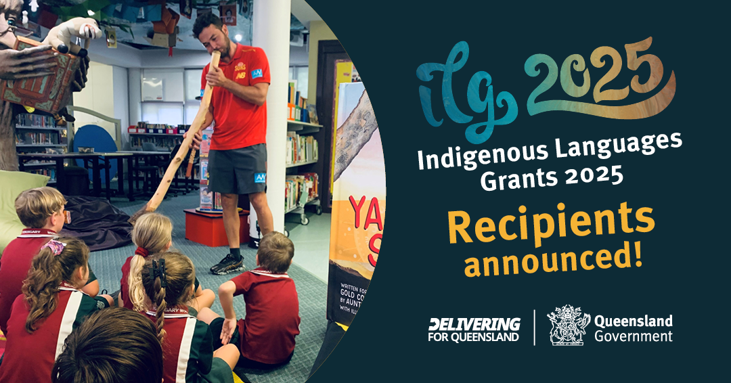
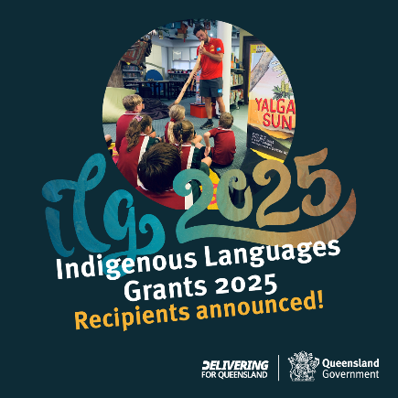

Social media tile 1 square (1080x1080px) Social media tile 1 landscape (1080x566px)

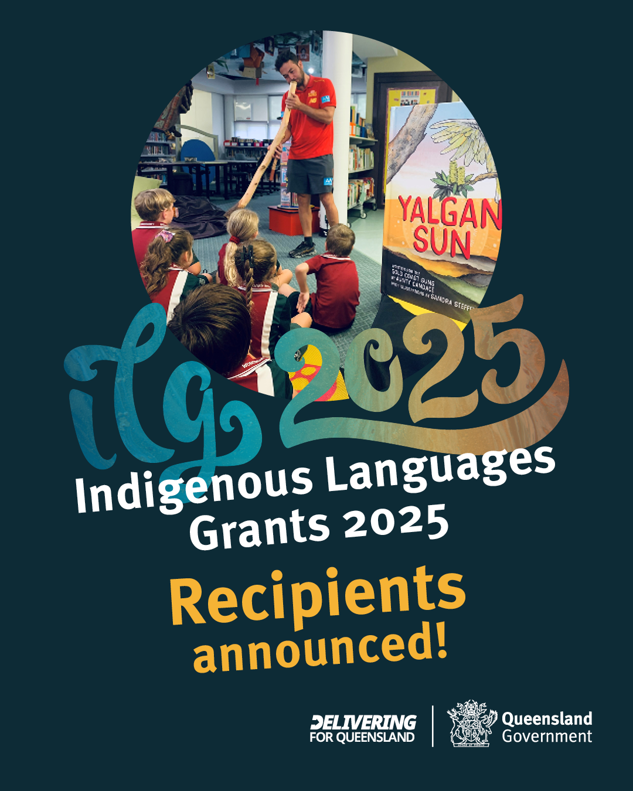
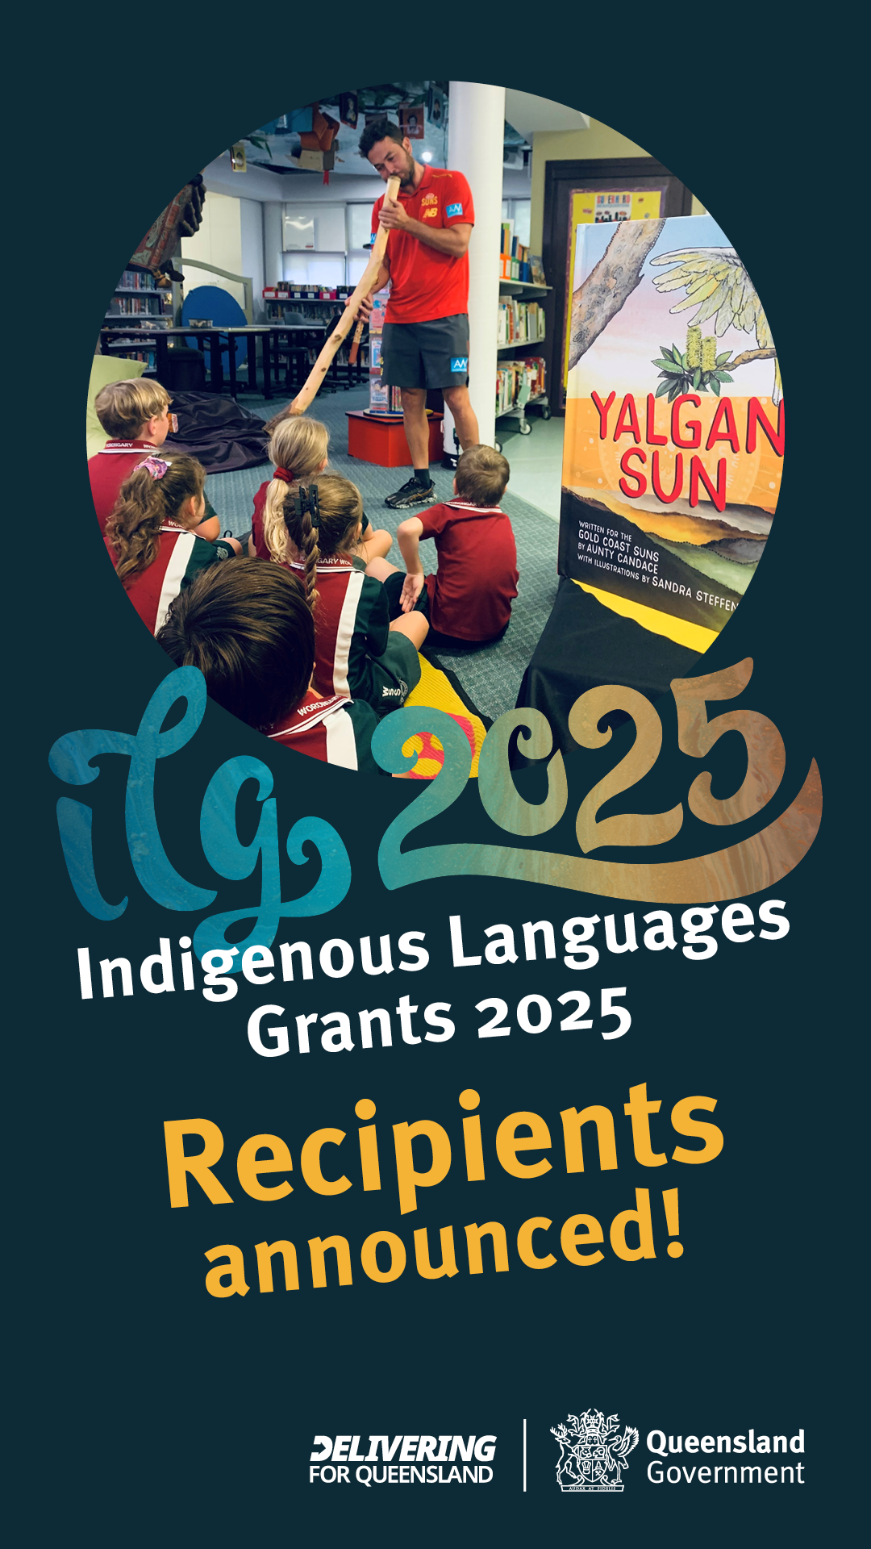
Social media tile 1 story (1080x1920px) Social media tile 1 portrait (1080x1350px)

Social media tiles design two
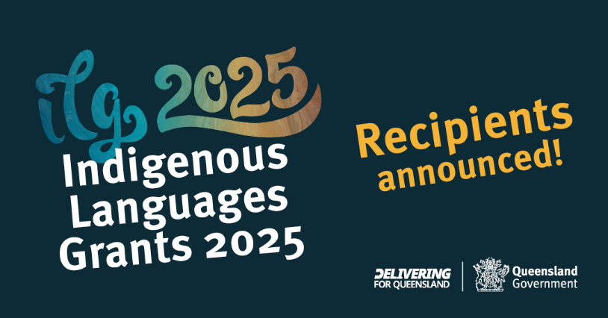
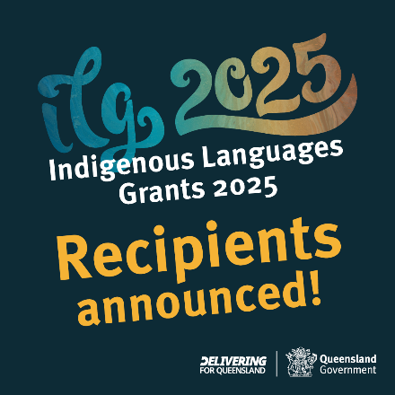
Social media tile 2 square (1080x1080px) Social media tile 2 landscape (1080x566px)

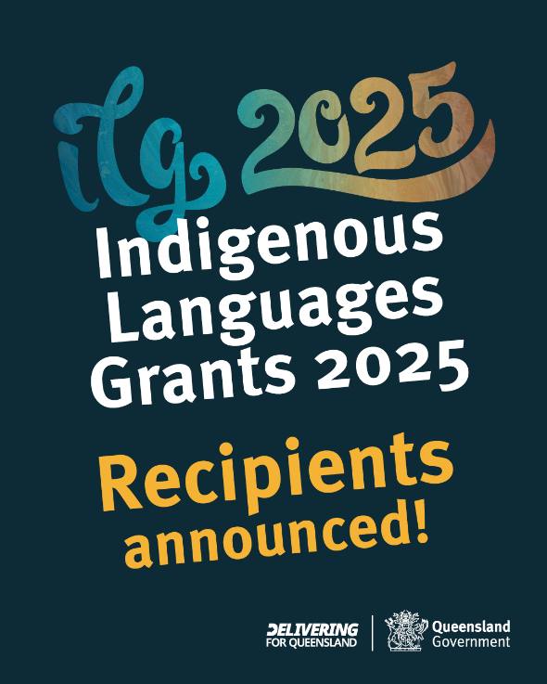
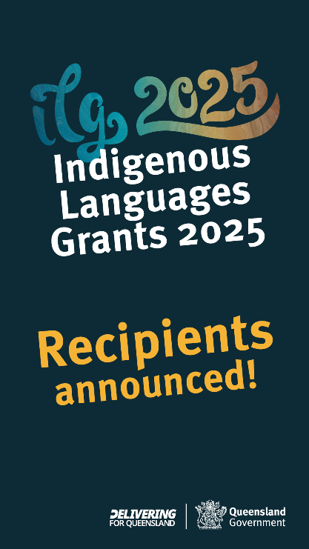

Social media tile 2 story (1080x1920px) Social media tile 2 portrait (1080x1350px)

Newsletter images
Newsletter image
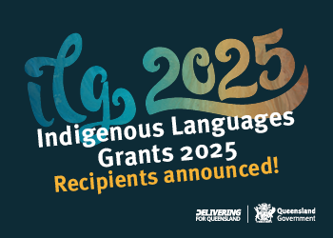
Newsletter image (350x250px)
Newsletter header
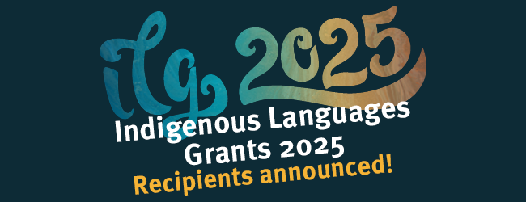
Newsletter header (650x250px)
Newsletter Footer

Newsletter footer (650x85)

Further information
Strategic Communication and Marketing
Department of Women, Aboriginal and Torres Strait Islander Partnerships and Multiculturalism

Email: Communications@dwatsipm.qld.gov.au

