Amplification pack

Disability Action Week 2025

Overview
Disability Action Week 2025 will be held from Sunday 23 November to Sunday 30 November, celebrating the invaluable contributions Queenslanders with disability make to our families, communities, workplaces, and the state’s economy.
This year’s theme, ‘Communicate. Connect. Create’, highlights the importance of accessible communication and the easy changes we can make to foster inclusion and improve access for everyone. The theme encourages Queenslanders to explore how accessible communication can be put into action in community settings, creating stronger connections and opportunities for all.

Resources
In this amplification pack you will find content and promotional assets showcasing accessibility in action including:
- content and promotional assets appropriate for general audiences
- content tailored for specific audiences including business, sports, community, and the arts sector
- images and image descriptions
- links to video content
- newsletter content.
For access to MP4 video files showing case studies of organisations that are doing great work in this space, to share directly on your channels, please email communication@families.qld.gov.au and include Disability Action Week in the subject line.
For more information about Disability Action Week 2025 including tips to make community groups, sporting clubs, workplaces, businesses and arts organisations more accessible, visit www.qld.gov.au/daw.

Social media content – general audiences
Social media post 1
Creative asset: Tjilala Brown-Roberts and Bradley Chatfield, Bangarra Dance Theatre and QPAC 90 second video - YouTube link: https://youtu.be/E7iVyIofsoA
🌟 Disability Action Week 2025: Let’s put accessibility centre stage! 🌟
From Sunday 23 November to Sunday 30 November, we’re acknowledging the contributions Queenslanders with disability make to our communities, families, and workplaces.
This year’s theme, ‘Communicate. Connect. Create’, is all about showing how easy changes to the way we communicate can make a big difference.
Watch as the Bangarra Dance Theatre and Queensland Performing Arts Centre share the importance of creating works for people with different accessibility needs through The Bogong’s Song.
💬 Access starts with you. Let’s work together to make Queensland a place where everyone belongs.
👉 Find out how to put accessibility in action at www.qld.gov.au/daw.
#DisabilityActionWeek #CommunicateConnectCreate
Social media post 2
Creative asset: Bruce Camplin and Barbara Easton, Suncorp Stadium 90 second video - YouTube link: https://youtu.be/YJAwIakABt8
📅 Plan ahead for accessibility in 2026! 📅
Accessible communication isn’t just for Disability Action Week — it’s a long-term investment in inclusion.
Start planning now for 2026 by making easy changes, whether it’s clear signage, inclusive event spaces, accessible signage, inclusive websites, and communication tools that work for everyone.
Bruce Camplin, Accessibility Coordinator, and Barbara Easton, People and Culture Manager, share Suncorp Stadium's ongoing journey to accessibility.
💬 Learn how to make accessibility part of your 2026 plans at www.qld.gov.au/daw.
#DisabilityActionWeek #CommunicateConnectCreate
Social media post 3
Creative asset: Harmonie Downes and Krizia Jefferies Rios, Brisbane Powerhouse 90 second video - YouTube link: https://youtu.be/YY4XT2Zlg3Q
Access changes lives.
From signage 🪧 to social media posts 📱, emails 📧 to exhibitions and events 🎭 —communication looks different for everyone and takes many forms.
Disability Action Week 2025 (Sunday 23 November to Sunday 30 November) celebrates accessible communication in action, with the theme ‘Communicate. Connect. Create’. ✨
Disability advocate, Harmonie Downes and Krizia Jeffriess Rios, Brisbane Powerhouse box office attendant, share how accessible venues help people to participate in all facets of community life in the way that they choose, ensuring an inclusive society for all.
Access starts with us. For tips to make a difference, event ideas and access to free training visit www.qld.gov.au/daw.
Let’s create a more inclusive Queensland! 🌏
#DisabilityActionWeek #CommunicateConnectCreate
Alternative image options | Image description (to be included at the bottom of the post. Alt text has also been added.)
Social media image 1  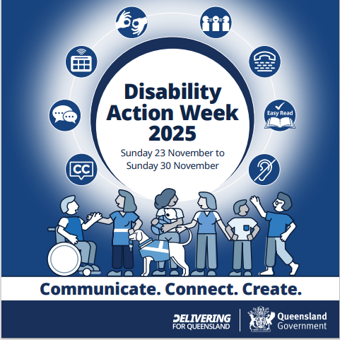 | [Image description: A white circle at the centre of the image reads ‘Disability Action Week 2025, Sunday 23 November to Sunday 30 November’. Another circle around that image connects eight blue and white icons that represent the different ways people communicate. From left to right these symbols are: Closed Captions, Conversation, Augmented and Alternative Communication (AAC device), Sign language interpretation, National Interpreter, Telephone-typewriter, Easy Read and Hearing access. Below the circles are illustrated images of people with and without disability in varying shades of blue and white, including a person using a wheelchair talking to another woman. Standing by her is a guide dog. At the centre of the image is a woman holding a baby talking to another woman, with two men standing to their right. Below the illustration, the words ‘Communicate. Connect. Create’ appear in blue over a white background. The Delivering for Queensland wordmark and Queensland Government Coat of Arms appears in white over a blue background at the bottom right of the image.]
Social media image 2  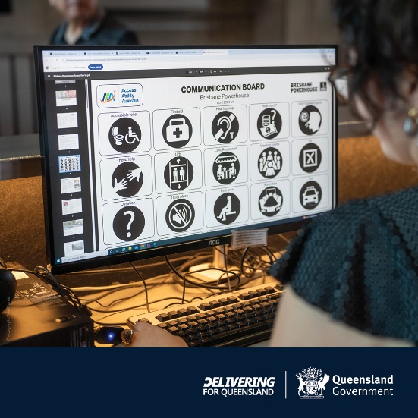 | [Image description: A woman with curly dark hair wearing a black dress looks at a computer screen. The Brisbane Powerhouse Communication Board is on the screen. The board shows various symbols representing help or assistance people might need, including symbols for first aid, hearing loop, rest area, quiet place, taxi, lifts and more. The Delivering for Queensland wordmark and Queensland Government Coat of Arms appears in white over a blue background at the bottom right of the image.]
Social media image 3  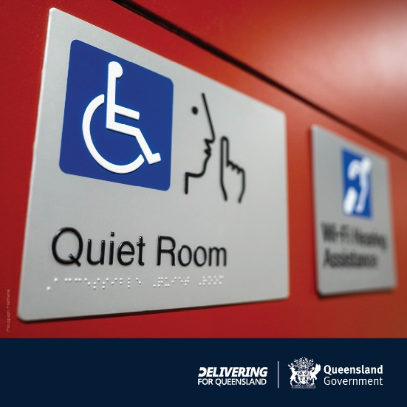 | [Image description: A sign on an orange wall that shows disability symbols including the symbol for wheelchair access, a face with one finger held up to the mouth to indicate quiet, and the words Quiet Room appear underneath. Braille is visible under the words Quiet Room. A second sign appears alongside the first but is blurred. The Delivering for Queensland wordmark and Queensland Government Coat of Arms appears in white over a blue background at the bottom right of the image.]

Social media content – by audience
Videos created for Disability Action Week 2025 showcase accessibility in action in real community settings.
This includes:
- Filming accessible performances of The Bogong’s Song, a children’s theatre performance produced by Bangarra Dance Theatre, performed at the Queensland Performing Arts Centre.
- Filming accessibility in action at Suncorp Stadium.
- Filming disability advocate Harmonie Downes at the Brisbane Powerhouse.
These videos highlight simple changes people can make to improve communication — particularly during events, at venues, and in other community settings.
The videos links are provided below.
Suggested social media content for key audiences is below.
Video content | Audiences | Suggested content
Creative asset: Harmonie Downes and Krizia Jefferies Rios, Brisbane Powerhouse 90 second video - YouTube link: https://youtu.be/YY4XT2Zlg3Q | Businesses  Events  Live entertainment  Hospitality  Retail  Venues  Community groups | 📅 Plan ahead for accessibility in 2026! 📅  Start planning now for 2026 by making easy changes, whether it’s clear signage, inclusive event spaces, accessible signage, inclusive websites, and communication tools that work for everyone.  Want to learn more? Watch disability advocate, Harmonie Downes and Krizia Jeffriess Rios, Brisbane Powerhouse box office attendant, discuss accessibility in action and why it’s good for business.  Let’s communicate, connect, and create a future where everyone can thrive.  💬 Learn how to make accessibility part of your 2026 plans at www.qld.gov.au/daw.  #DisabilityActionWeek #CommunicateConnectCreate
The Bogong’s Song by Bangarra Dance Theatre performed at QPAC  Creative asset: Tjilala Brown-Roberts and Bradley Chatfield, Bangarra and QPAC 90 second video - YouTube link: https://youtu.be/E7iVyIofsoA | Arts sector  Events industry  Aboriginal peoples and Torres Strait Islander peoples  Children and young people | 🌟 Disability Action Week 2025: Let’s put accessibility centre stage! 🌟  From Sunday 23 November to Sunday 30 November, we’re celebrating the contributions Queenslanders with disability make to our communities, families, and cultural heritage.  This year’s theme, ‘Communicate. Connect. Create’, highlights how small changes to the way we communicate can make a big difference.  Watch as the Bangarra Dance Theatre and Queensland Performing Arts Centre share the importance of creating works for people with different accessibility needs through The Bogong’s Song.  Inclusive performances, accessible workshops and enhanced venue access all help to create spaces where culture, language, and stories can be shared by people of all ages and backgrounds.  💬 Access starts with you. Let’s work together to make Queensland a place where everyone belongs.  👉 Find out how to put accessibility in action at www.qld.gov.au/daw.  #DisabilityActionWeek #CommunicateConnectCreate
Creative asset: Bruce Camplin and Barbara Easton, Suncorp Stadium 90 second video - YouTube link: https://youtu.be/YJAwIakABt8 | Sports and recreation  Community events  Customer service | 🏉 Inclusion is how Queensland wins! 🏆  Queensland’s winning sporting teams show the power of teamwork and inclusion — and your club can do the same. Accessible communication ensures everyone can play, volunteer, and cheer, creating stronger, more connected communities.  Watch Bruce, Accessibility Coordinator, and Barbara, People and Culture Manager, share Suncorp Stadium's ongoing journey to accessibility.  Ready to take on the challenge?  Here’s how your club can put access into action:  🗓️ Provide clear, easy-to-read game schedules.  🚪 Ensure signage and facilities are accessible for all.  📝 Use plain language for registration and event materials.  Let’s communicate, connect, and create sporting communities where everyone feels part of the team — on and off the field.  💬 Learn more about accessibility in action at www.qld.gov.au/daw.  #DisabilityActionWeek #CommunicateConnectCreate

Image descriptions to accompany social posts
Alternative image options | Image description (to be included at the bottom of the post. Alt text has also been added.)
Social media image 1  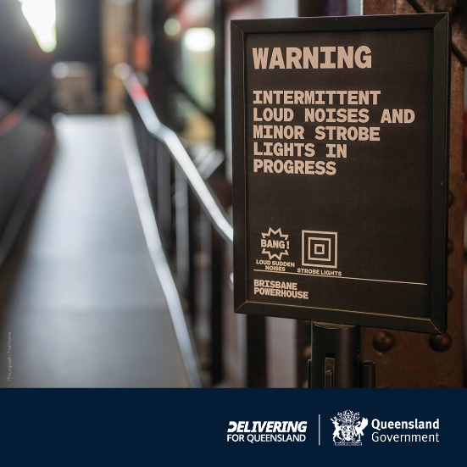 | [Image description: A ramp is visible on the left of the image. On the right is a sign that reads: Warning. Intermittent loud noises and minor strobe lights in progress. There are also two symbols – one reading Bang in a jagged speech bubble and the other shows multiple squares inside one image. Below that reads strobe lighting. The Brisbane powerhouse logo is below the two symbols. The Delivering for Queensland wordmark and Queensland Government Coat of Arms appears in white over a blue background at the bottom right of the image.]
Social media image 2  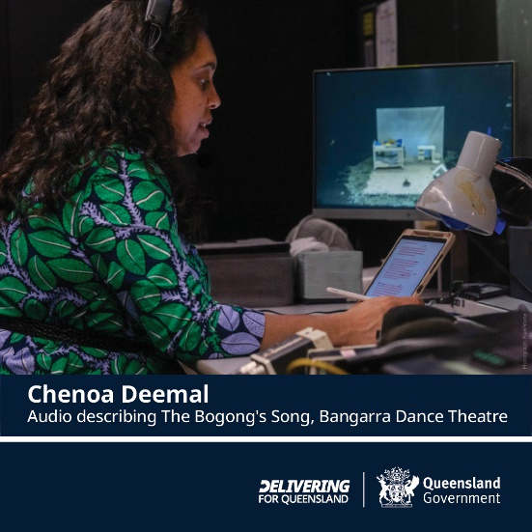 | [Image description: Picture from audio description of The Bogong’s Song, read by Chenoa during audio described performance. The photograph shows a woman wearing a green and blue shirt with long dark curly hair reading from a laptop. In front of her are various screens, recording and sound equipment. The Delivering for Queensland wordmark and Queensland Government Coat of Arms appears in white over a blue background at the bottom right of the image.]
Social media image 3  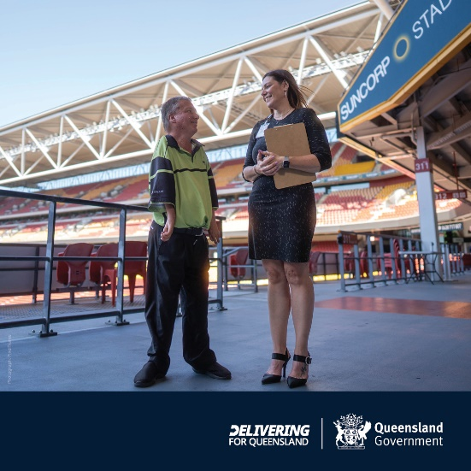 | [Image description: A man with short hair, wearing a high visibility shirt and black pants is looking at a woman with shoulder-length brown hair in a grey dress. Both are smiling. Behind them are seats, railings and a sign that reads ‘Suncorp Stadium’. The Delivering for Queensland wordmark and Queensland Government Coat of Arms appears in white over a blue background at the bottom right of the image.]

Newsletter content
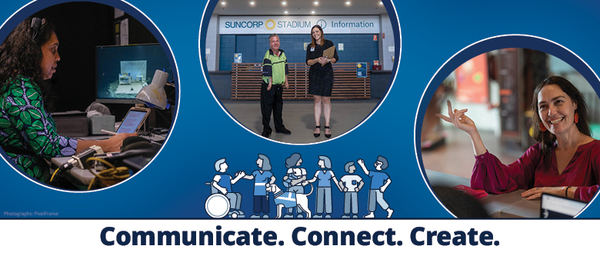
[Image description: A horizontal blue tile. On the left is a white circle with a picture of the audio description of The Bogong’s Song. The photograph shows a woman wearing a green and blue shirt with long dark curly hair reading from an electronic device. In front of her are various screens, recording and sound equipment. A second circle in the middle of the tile shows two people in front of the Suncorp Stadium information desk. One is dressed in a high-visibility shirt and the other is dressed in corporate attire. To the right, a third circle features a patron in a plum-coloured top standing and smiling at an information desk. At the bottom middle of the image, there are illustrated images of people with and without disability in varying shades of blue and white, including a person using a wheelchair talking to another woman. Standing by her is a guide dog. At the centre of the image is a woman holding a baby talking to another woman, with two men standing to their right. Below this illustration, the words ‘Communicate. Connect. Create’ appear over a white background.]
Putting access centre stage this Disability Action Week
Disability Action Week recognises the contributions Queenslanders with disability make in our families, communities, workplaces and to our state’s economy.
The Disability Action Week 2025 theme is ‘Communicate. Connect. Create’, highlighting the power of accessible communication to foster inclusion and connection for everyone.
Whether it’s clear signage, inclusive event spaces, or accessible social media posts — we can all play a part in creating communities where everyone feels welcome and included. Access starts with us.
Watch how The Bogong’s Song by Bangarra Dance Theatre and Queensland Performing Arts Centre, Suncorp Stadium and Brisbane Powerhouse are demonstrating accessible communication in action in our communities.
For tips on how to make your community group, sports club, workplace, business or arts organisation more accessible visit www.qld.gov.au/daw.
Let’s work together to create a Queensland where everyone can access the information they need to thrive.
Tip: Don’t forget to include a ‘view online’ link when sending out e-newsletters. Viewing documents online allows people to enlarge text or use browser accessibility tools like screen readers.

