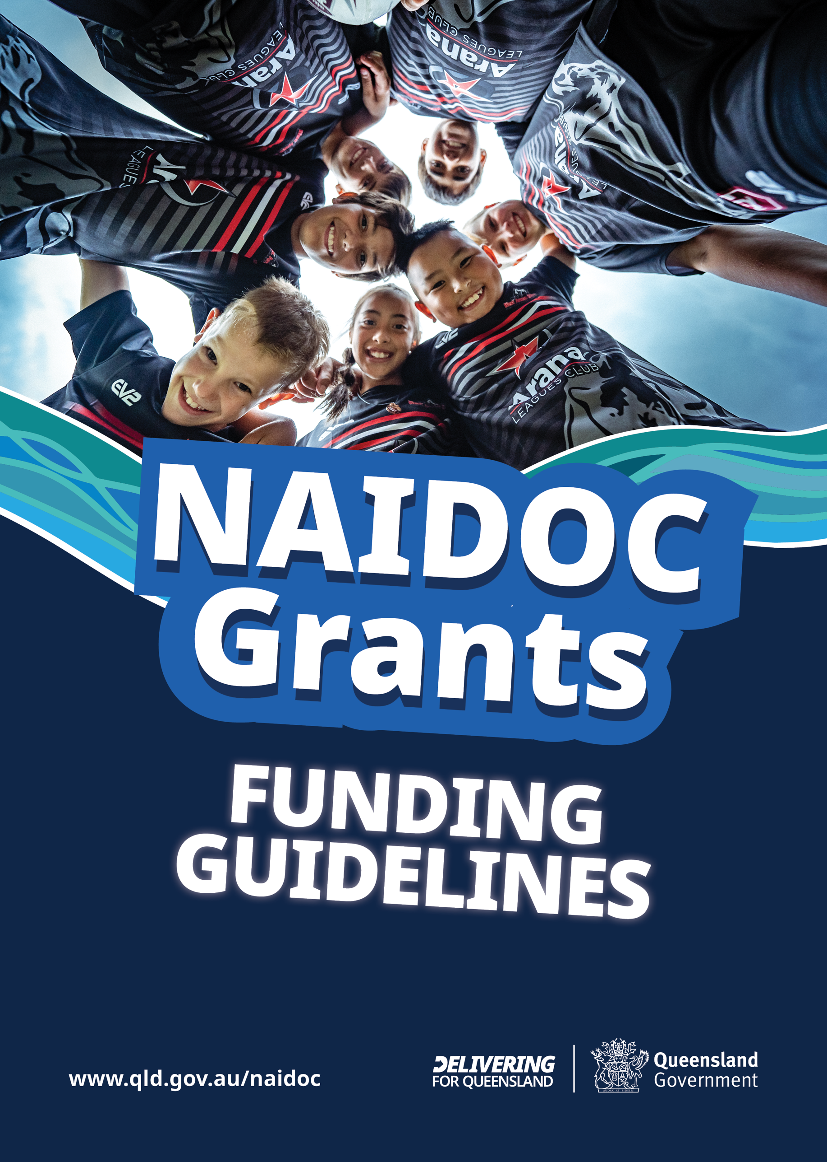
2026 NAIDOC Grant Funding Guidelines

Introduction
National NAIDOC Week celebrations are held across Australia in the first week of July (5 – 12 July 2026) to recognise the history, culture and achievements of Aboriginal and Torres Strait Islander peoples.
NAIDOC Week is an opportunity for all Australians to learn about First Nations cultures and histories and participate in celebrations of the oldest, continuous living cultures on earth.
The 2026 NAIDOC theme, Fifty Years of Deadly, marks a significant milestone for NAIDOC. It’s a tribute to the people who built this movement; the Elders who stood firm, the organisers who made space, the artists who turned resistance into expression, and the communities who keep showing up, year after year.
The Department of Women, Aboriginal and Torres Strait Islander Partnerships and Multiculturalism (DWATSIPM) supports NAIDOC through provision of grant funding to eligible entities to host events meeting grant funding criteria.
This document outlines the eligibility criteria, application process, funding conditions and reporting requirements for DWATSIPM’s 2026 NAIDOC Grants.

Objectives
The objectives of the NAIDOC Grants are to:
- Promote and raise awareness of the 2026 NAIDOC theme “Fifty years of Deadly”
- Enable opportunities for all Queenslanders to learn, share and grow, through the showcasing of local Aboriginal and Torres Strait Islander stories, art and cultural activities.
- Strengthen respectful relationships between Aboriginal and Torres Strait Islander peoples and non-Indigenous peoples.
- Promote equity, inclusion and social cohesion.

Funding Available
The total 2026 NAIDOC Grant Funding is $145,000 (excluding GST) for the 2025-26 financial year.
- Grants of up to $2,500 (excluding GST) are available per applicant.
- Funding is provided directly to Eligible Applicants.
Grant funding, subject to scheduling and completion of required financial approval, is expected to be released to successful applicants in May 2026.

Eligible events and activities
To be eligible for DWATSIPM grant funding, NAIDOC activities and events are to be held in Queensland during NAIDOC week and co-designed with Aboriginal peoples and/or Torres Strait Islander peoples.
Examples of eligible events are provided below. This list is not exhaustive, and you are welcome to submit a proposal for a different type of event or activity that meets the objectives of the grant funding.
- Cultural displays that promote an understanding of, and respect for, Aboriginal or Torres Strait Islander traditions, customs, histories and cultural heritage.
- Celebrations showcasing local Aboriginal or Torres Strait Islander artworks, dance groups, musicians, singers and entertainers.
- Resources or materials (such as booklets, posters, videos, websites or podcasts) that acknowledge and raise awareness of Aboriginal and Torres Strait Islander peoples’ cultures.
- Sporting and/or recreational activities that promote reconciliation between local Aboriginal, Torres Strait Islander and non-Indigenous community members including children and young people.
- Community-based and community-driven initiatives such as yarning circles or speaking events that foster conversations about reconciliation, inclusion, equity and related matters which provide a harmonious, creative and collaborative way of communicating in a safe and supported environment.
- Food displays and stalls demonstrating the preparation and cooking of traditional foods and bush tucker.
Note: Events that are potentially contentious, traumatic and/or triggering for Aboriginal and Torres Islander peoples will not be supported.
The health and wellbeing of our Aboriginal and Torres Strait Islander community is a priority. Applicants should carefully consider whether events and activities can be safely delivered. Where relevant, successful events and activities will need to comply with the public health requirements.
A range of resources to support communities during NAIDOC Week are available on NAIDOC website at https://www.naidoc.org.au/.

Who can apply?

Applicants wishing to apply for a 2026 NAIDOC Grant must:
- be based, and deliver services, in Queensland; and
- have a valid Australian Business Number (ABN); and
- if the event or activity involves children or young people, compliance with the ‘working with children’ legislation will be required. See the Working with Children Check Requirements in the Application Process steps.

Eligible applicants include:
- a company incorporated in Australia
- a company limited by guarantee
- an incorporated trustee on behalf of a trust
- an incorporated association
- a registered charity or not-for-profit organisation
- a local government body

Applicants not eligible to apply:
- a Queensland government department, agency and statutory authority
- an Australian government department, agency and statutory authority
- a Member of Parliament
- an individual
- an unincorporated association
- an organisation not delivering services in Queensland
- applicants without a valid ABN
- public or private schools (including school parent associations), kindergartens, childcare centres and pre-schools
- previous applicants with an outstanding acquittal

Eligible grant funding expenses
- equipment and venue hire
- communication and/or promotional materials reflecting NAIDOC’s 2026 theme.
- consumable materials and supplies
- talent and entertainment
- catering and produce

Ineligible grant funding expenses
- salary and wages
- administration and overhead costs
- activities that form part of the organisations core business or are considered routine operations of the applicant
- funding of research, trials or feasibility studies
- insurances
- prizes or gifts
- alcoholic beverages
- retrospective (past) activities
- capital equipment or works
- activities or goods not directly related to the event (including auspice fees)

Disclaimer
The Queensland Government reserves the right to amend these guidelines or cancel the program at any time without notice. Submission of an application does not guarantee funding.

Application Process

Step 1: Review Guidelines
Applicants must carefully review these guidelines to ensure they meet the eligibility criteria.

Step 2: Working with Children Check requirement
Applicants may require volunteers or staff to hold a blue card for events that include children or young people. To ensure you meet the requirements for the ‘Working with Children Check’, please visit https://www.bluecard.qld.gov.au/bluecardprocess.html.

Step 3: Submit an application
Applications open on 23 March 2026 and close on 10 April 2026.
You can lodge your application through the SmartyGrants website https://datsip.smartygrants.com.au/naidoc2026 which will direct you to the application form.

Should you need any assistance, please refer to the SmartyGrants Help Guide for Applicants, additionally staff from our regional offices can assist applicants to upload an application on SmartyGrants.

Key Dates
Please note: all dates are indicative and may change subject to scheduling and financial approvals.
Grants Open – 23 March 2026
Grants Close– 10 April 2026*
Successful applicants announced – 24 April 2026
NAIDOC Week – 5 – 12 July 2026
* For communities impacted by Cyclone Narelle in Far North Queensland late applications will be accepted. The department will work with communities to understand community plans for NAIDOC and will allocate funds for Far North Queensland to support late requests.

Assessment Process
Grant applications will be assessed by DWATSIPM against the Assessment Criteria and eligibility conditions outlined in these Funding Guidelines, using the evidence you provide.

Successful applicants
Applicants will be advised via email of the outcome of their grant application by 24 April 2026.

All grant recipients will be required to:
- enter into, and comply with, a funding agreement and its terms and conditions.
- acknowledge the Queensland Government funding with a Queensland Government crest on any and all promotional material associated with the funded event.
- submit an Event and Financial (Acquittal) Report by the specified 14 August 2026.
- immediately inform DWATSIPM via email of any proposed changes to the funded event, e.g. change in activities, dates, and locations.

Funding Conditions

Grant recipients must:
- Use the funds only for approved purposes.
- Retain all application evidence, including receipts, invoices and bank transactions relating to the grant funding.

Tax Implications
The tax implications of any payments made to an applicant under this program may differ
depending on the applicant’s circumstances. The Queensland Government is unable to provide taxation advice and accordingly we recommend seeking your own professional advice to determine any taxation implications that may apply.
The Australian Taxation Office has information that may also assist you at www.ato.gov.au.

Reporting and Acquittal
Successful applicants must retain all evidence of funded expenses, including receipts, invoices, and bank transactions, for audit purposes and reporting under the 2026 NAIDOC Grants program.
Following the delivery of the funded initiative, you are required to complete the Acquittal Report included in your SmartyGrants application detailing delivered activities, outcomes and financial acquittals. The failure to do so within 30 days post the event, without an approved extension, will result in ineligibility for future grant programs.

Promotional Opportunities
The Department of Women, Aboriginal and Torres Strait Islander Partnerships and Multiculturalism may contact grant recipients for potential promotional and/or advertising opportunities in relation to the 2026 NAIDOC grants and associated activities.

Assessment Criteria
Criteria | Weighting %
Demonstrates how the event or activity supports the program objectives of the 2026 NAIDOC grants. | 30
Demonstrates how Aboriginal and/or Torres Strait Islander people will be/have been included in the design and/or delivery of the event or activity. | 30
Presents a plan for the event or activity including proposed methods for promotion. | 15
Presents a budget that is complete, realistic, provides value for money, and clearly outlines how the grant funding will be spent. | 15
Demonstrates capacity and experience to manage and deliver the event or activity (including planning, implementation, and evaluation of its success). | 10

Recovery of Funds
The Queensland Government reserves the right to recover any or all grant funds in the following circumstances:

Unspent Funds
Any grant funding that is not expended by the recipient for the approved purposes must be returned to the Queensland Government within 30 days of the unspent funds being identified through the acquittal process.

Misuse of Funds
If grant funds are found to have been used for purposes other than those approved, the Queensland Government will recover the full amount of the grant. This includes any funds that were:
- Spent on ineligible activities or expenses.
- Used in breach of the funding conditions.

Non-Compliance
Failure to comply with the reporting, acquittal, or other obligations outlined in these guidelines will result in the Queensland Government seeking repayment of the grant in part or in full.

Repayment Process
Recipients required to return or repay funds will be notified in writing, including details of the amount to be repaid and the repayment process. All repayments must be made within 30 days of notice issue date.

Human Rights Consideration
The intention of the Human Rights Act 2019 (the Act) is to ensure every person in Queensland is treated equally and without discrimination.
Although the eligibility criteria for the NAIDOC grants is not extended to all Queenslanders and therefore may limit the rights of those that are unable to access it, this is described as reasonable and justifiable under the Act (Section 13(2)) as the intent of the NAIDOC Grants aims to achieve the purpose of the Act.

Need help in your language?
Call 1800 512 451 and ask for an interpreter.
If you require further assistance, please contact the Department of Women, Aboriginal and Torres Strait Islander Partnerships and Multiculturalism via email at: naidocgrants@dwatsipm.qld.gov.au

Contact us
For more information about the grants, including the guidelines, terms and conditions and how to apply, please contact your local regional office or email naidocgrants@dwatsipm.qld.gov.au

A “company limited by guarantee” is a specialised form of public company designed for non-profit organisations. In Australia companies limited by guarantee are subject to the Corporations Act 2001 (Cth) and administered to by the Australian Securities and Investments Commission (ASIC).

